DT 169 TIMBER PRODUCT TECHNOLOGY Semester 1 2017/2018
Plan, design and cost a Kitchen to suit the floor plan Fig. 1.
Discuss the concept of your design, your influences and preferences. Factors that you considered such as working triangle, style, complexity of design, manufacturing process, material costs, ergonomics and costs. Where did you carry out your research?
Items required: Full list of carcases units (carcases come fully assembled). Full list of doors (to include material type, door style and sizes). Full list of Appliances to include sizes and costs. Full list of all other components such as worktops, worktop joiners gables / returns, kickers, cornices and pelmets, handles, legs, fixtures and fittings to include details such as code or order number from manufacturer.
Drawings: Provide the following drawings:
- Floor plan showing kitchen layout.
- Elevation of kitchen.
- 3D image of kitchen.
Final Costing: Provide a complete costing on kitchen components using figures from your researched company. Include any data/ information sheets, prices list, brochures and samples in your appendix.
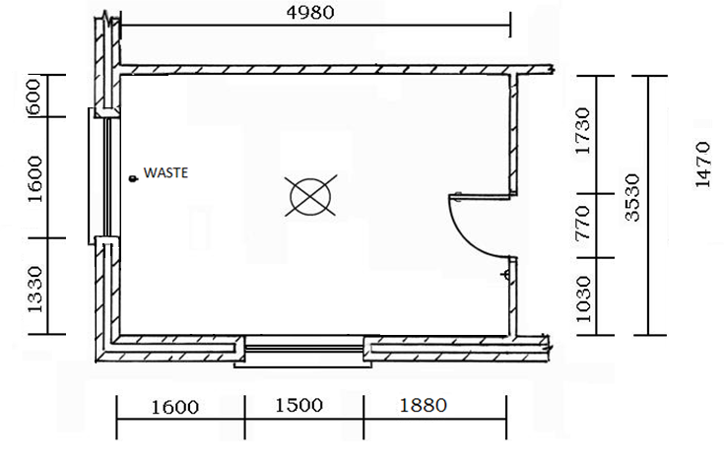
Tip: Use excel to create a table of components and format cells to carry out calculations.

Fig. 1 Kitchen Floor Plan NTS
