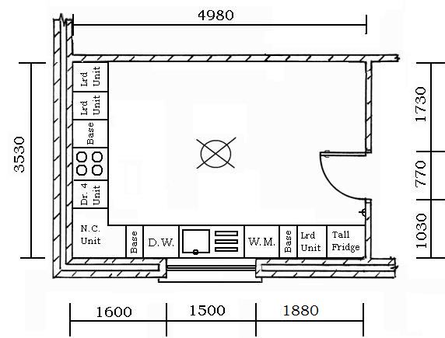
Planning a Kitchen work sheets

Above is the floor plan of a room showing the layout of the kitchen and the Base units. Can you identify and list the units shown in the plan?
List of Base units
No. | Width of unit | Type of unit
Re-list Groups of Base Units required
No. | Width of unit | Type of unit

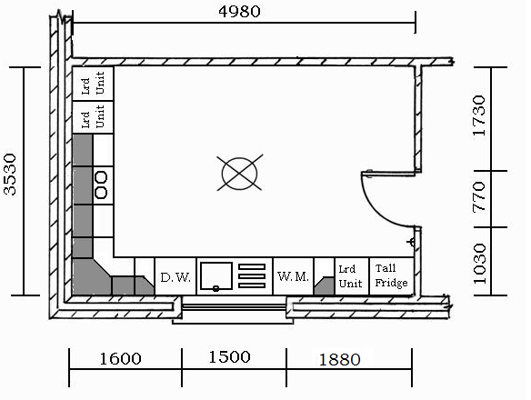
Above is the floor plan of a room showing the layout of the kitchen and the Wall Units. Can you identify and list the units shown in the plan?
List of Wall Units
No. | Width of unit | Type of unit

Re-list Groups of Wall Units required
No. | Width of unit | Type of unit

Final List of Units and Doors
No. | Width of unit | Type of unit | No. of Doors | Width | Length

